SIMATS ENGINEERING (SAVEETHA SCHOOL OF ENGINEERING) Department of Computer Science and Engineering
NAME: Tony Winston T
REG NO: 1924260006
COURSE CODE: 0704
ASSESSMENT TOOL 1 – Constraint-Based Problem Solving
Annex: 3. Constraint-Based Problem Solving
DNS Resolution – Google
Open the website: Google: https://www.google.com/?zx=1787560655258
Start Wireshark before opening the browser.
Constraint You are allowed to inspect only DNS packets.
Task
Identify the packet containing the DNS response that resolves www.google.com.
Digital response Select the correct packet number from the options.
Wireshark filter: Packet 75

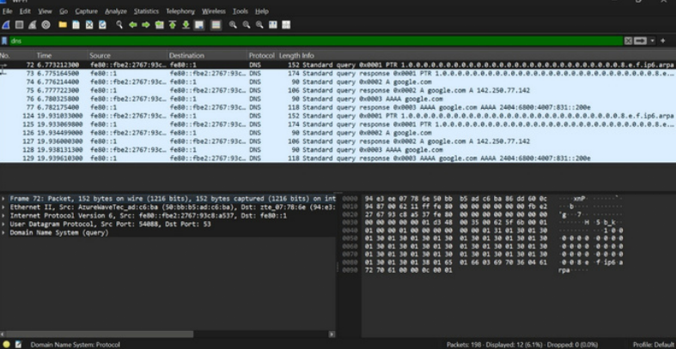
HTTPS Web Access – Wikipedia
Clear the browser cache, start Wireshark, and open:
Wikipedia: https://www.wikipedia.org/
Constraint
You may use only one display filter and cannot inspect browser developer tools.
Task
Identify the transport-layer protocol carrying the encrypted web connection.
Options
TCP
UDP
ICMP
ARP
Correct answer: TCP
FTP Traffic Challenge – Real FTP Test Service
Use a public FTP test service provided for testing:
Rebex FTP Test Server: https://test.rebex.net/
Capture the connection using an FTP client

Constraint
You may use only one port-based filter.
Task Identify the FTP control connection.
Options
Port 21
Port 25
Port 53
Port 161
Wireshark filter: Port 21
SMTP Traffic Identification – Mailtrap Sandbox
Use an SMTP testing environment such as:
Mailtrap Email Sandbox: https://mailtrap.io/email-sandbox/
Configure the provided sandbox SMTP credentials in a mail-testing client or application and capture the connection.
Constraint
Students can inspect only packets belonging to the configured SMTP connection.
Task Identify the application protocol responsible for transmitting the outgoing email.
Options
SMTP
POP
DNS
SNMP
Correct response: SMTP

